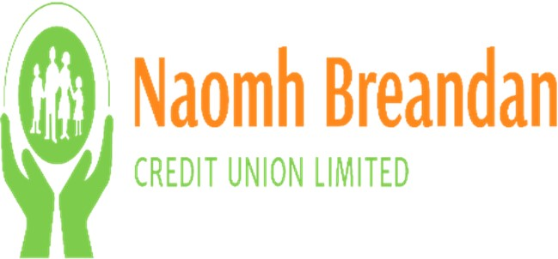

Social and Cultural Fund 2022
Application Form
Group/Organisation Name
Account Number (if applicable)
FOR OFFICE USE ONLY

Date Received: _______________________

Account Number: _______________________ (if applicable)

Community Funding Initiative Committee Decision:_________________________________

Board Decision:_________________________

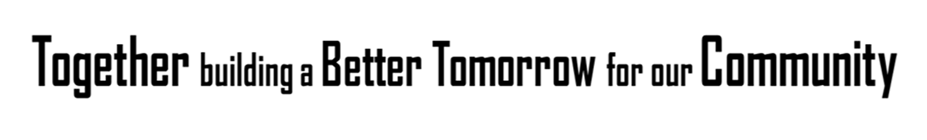
All applications are to be returned by 5.00 pm on 31st August 2022 to Naomh Breandáin Credit Union Limited
All additional information to support your application must be submitted as a separate document and attached to this Application Form.

Title of your Organisation ________________________________________________________
Organisation/Group Address ________________________________________________________
_________________________________________________________
Title of your Project _________________________________________________________
Please identify the status of your organisation (Please tick one)
- Community or voluntary group
- Registered Charity Charity Registration Number ___________
- Charity or not-for-profit
- Club or association
- Other Please Specify ____________________________________
Please indicate which of the following your organisation has in place (Please tick one)
- Written Constitution/Memorandum & Articles (Please submit a copy with Application)
- Set of Rules (Please submit a copy with Application)
- None
Please confirm your organisation is ‘Not for Profit’
- Yes
- No
Does your organisation have audited accounts
- Yes
- No
Please attach most recent set of accounts (audited/unaudited) with the application (If available)
Are you a member of a larger organisation, or a member of a national charity
- Yes
- No
Date of establishment of organisation ________________________________________
Contact Name ________________________________________
Position held within the organisation ________________________________________
Contact Number_________________ E-mail address ______________________________

Contact Name ___________________________________________________________
Position held within the organisation ________________________________________
Contact Number_____________________ E-mail address_______________________
We will need a copy of each signatories ID and Address verification
__________________________________________________________________________________
Briefly describe your organisation’s main purpose and what benefits does it bring to the local community (approx. 250 words)
________________________________________________________________________
________________________________________________________________________
________________________________________________________________________
________________________________________________________________________
________________________________________________________________________
________________________________________________________________________
________________________________________________________________________
________________________________________________________________________

Briefly describe how you intend to spend the monies for this project (approx. 250 words) ______________________________________________________________________________________________________________________________________________________________________________________________________________________________________________________________________________________________________________________________________________________________________________________________________________________________________________________________________________________________________________________________________________________________________________________________
What is the start date for the project? __________________________________
What is the completion date for the project? __________________________________
State whether this is a new, ongoing or a repeated project
- New
- On-going
- Repeat

Name of location in which your project will serve the community? i.e. parish/town/village
________________________________________________________________________

How do you currently fund existing activities? (approx. 250 words)
________________________________________________________________________
________________________________________________________________________
________________________________________________________________________
________________________________________________________________________
________________________________________________________________________
________________________________________________________________________
________________________________________________________________________
________________________________________________________________________

State the amount of funding you are seeking ____________________________________
Total Cost of Project _______________________________________________________

Please provide a breakdown of the overall cost of the project (approx. 250 words)
________________________________________________________________________
________________________________________________________________________
________________________________________________________________________
________________________________________________________________________
________________________________________________________________________
________________________________________________________________________
________________________________________________________________________
________________________________________________________________________

If the total cost of the project is more than you are requesting, please indicate how the
shortfall will be met and the source(s) providing the shortfall
________________________________________________________________________
________________________________________________________________________
________________________________________________________________________
________________________________________________________________________
________________________________________________________________________
________________________________________________________________________
________________________________________________________________________
________________________________________________________________________

Describe in detail how Naomh Breandáin Credit Union will be recognized as a sponsor and
what you will do to help ensure the Credit Union gets as much exposure as possible from
any involvement?
________________________________________________________________________
________________________________________________________________________
________________________________________________________________________
________________________________________________________________________
________________________________________________________________________
Is the Organisation/Group in receipt of public or private funding?
_________________________________________________________________________
Is statutory approval/permission/consent required for this project to proceed? ________
Please furnish a copy of any such approval/permission/consent with this application form

If the project involves the development of property, does your group own/lease the land or property? __________________________________________________________________
Please furnish evidence of ownership/ copy of lease with this application.
I confirm that I have read and agree with the terms and conditions of the fund and that I agree to abide by the terms and conditions. I certify that the information given in this Application Form is to the best of my knowledge true and accurate.
Signed on behalf of the organisation:
Signed _______________________ Signed ______________________________
Position Held ______________________ Position Held _________________________
Print Name _______________________ Print Name __________________________
Date _____________________________ Date ______________________________

